b3_ana_5
Chen Xing
2022-05-05

对b3进行 针对性分析

必要的包

开始分析

数据准备
# 数据导入
dt <- read.csv("/Users/placenameday/R study/edf_demo/data/processed/eye_tacking/ea/data/inner_dt_aoi_re.csv")

fangfa
mix_e_f <- function(dt, bname, sname, a, metri){
# 数据准备
dtc2 <- dt %>% filter(block_name==bname, stim==sname, AOI %in% a) %>%
group_by(maas_g, tgjl_g, sas_g, participant_phone, AOI) %>%
summarise(fc=mean(!!sym(metri), na.rm=T), maas=mean(maas), tgjl=mean(tgjl), sas=mean(sas)) %>%
filter(!is.na(fc)) %>%
ungroup() %>%
convert_as_factor(participant_phone, AOI) %>%
select(participant_phone, AOI, tgjl, maas, sas, fc)
# 极端值处理
outdata <- dtc2 %>%
group_by(AOI) %>%
identify_outliers(fc)
dtb3_r <- anti_join(dtc2, outdata)
outdata2 <- dtb3_r %>%
group_by(AOI) %>%
identify_outliers(fc)
dtb3_r2 <- anti_join(dtb3_r, outdata2)
outdata3 <- dtb3_r2 %>%
group_by(AOI) %>%
identify_outliers(fc)
dtb3_r3 <- anti_join(dtb3_r2, outdata3)
outdata4 <- dtb3_r3 %>%
group_by(AOI) %>%
identify_outliers(fc)
dtb3_r4 <- anti_join(dtb3_r3, outdata4)
outdata5 <- dtb3_r4 %>%
group_by(AOI) %>%
identify_outliers(fc)
# 结果输出
mixed_maas = lmer(fc ~ maas*AOI + (1 | participant_phone), data = dtb3_r4)
mixed_sas = lmer(fc ~ sas*AOI + (1 | participant_phone), data = dtb3_r4)
mixed_two = lmer(fc ~ maas*sas*AOI + (1 | participant_phone), data = dtb3_r4)
# maas 结果
maas_t <- tab_model(mixed_maas, dv.labels = metri)
maas_p1 <- plot_model(mixed_maas, show.values = TRUE, value.offset = .3, title = metri)
maas_p2 <- plot_model(mixed_maas, type = "pred", terms = c("maas", "AOI"), title = metri, axis.title = metri)
maas_results <- list(table=maas_t, p1=maas_p1, p2=maas_p2)
# sas 结果
sas_t <- tab_model(mixed_sas, dv.labels = metri)
sas_p1 <- plot_model(mixed_sas, show.values = TRUE, value.offset = .3, title = metri)
sas_p2 <- plot_model(mixed_sas, type = "pred", terms = c("sas", "AOI"), title = metri, axis.title = metri)
sas_results <- list(table=sas_t, p1=sas_p1, p2=sas_p2)
# two 结果
two_t <- tab_model(mixed_two, dv.labels = metri)
two_p1 <- plot_model(mixed_two, show.values = TRUE, value.offset = .3, title = metri)
two_p2 <- plot_model(mixed_two, type = "pred", terms = c("maas", "sas", "AOI"), title = metri, axis.title = metri)
two_p3 <- plot_model(mixed_two, type = "pred", terms = c("sas", "maas", "AOI"), title = metri, axis.title = metri)
two_results <- list(table=two_t, p1=two_p1, p2=two_p2, p3=two_p3)
f <- list(maas_results, sas_results, two_results)
show(f)
}

参数定义
bname <- c("b3")
sname <- 1
a <- c("b3_ne","b3_pos", "b3_neg", "b3_thr")
mlist <- c("fc", "afd", "dff", "ffd", "pd", "dw", "asa", "sc", "sad", "asd", "spv")

分析
map(mlist, mix_e_f, dt=dt, bname=bname, sname=sname, a=a)
## [[1]]
## [[1]]$table
##
## [[1]]$p1
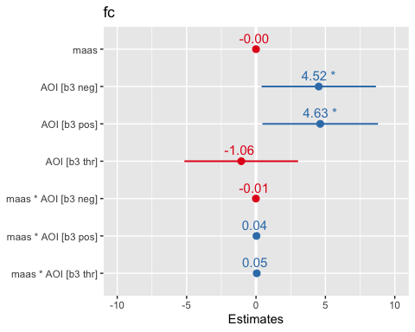
##
## [[1]]$p2
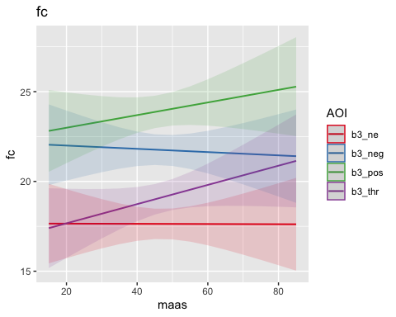
##
##
## [[2]]
## [[2]]$table
##
## [[2]]$p1
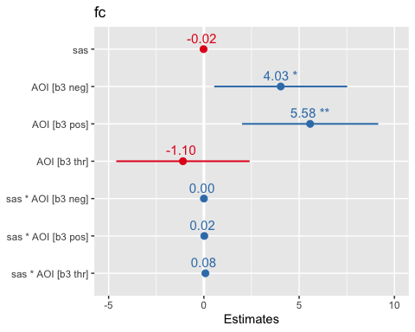
##
## [[2]]$p2
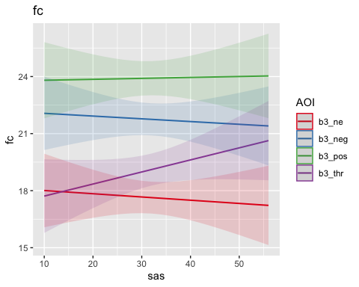
##
##
## [[3]]
## [[3]]$table
##
## [[3]]$p1
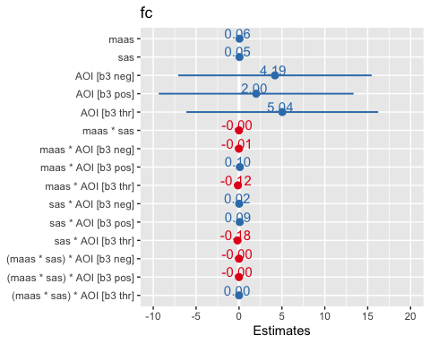
##
## [[3]]$p2
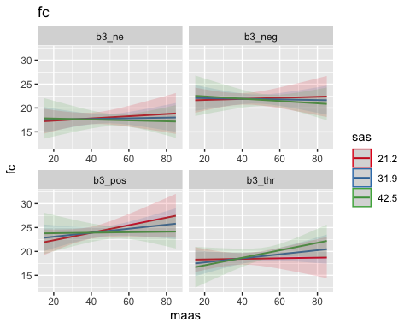
##
## [[3]]$p3
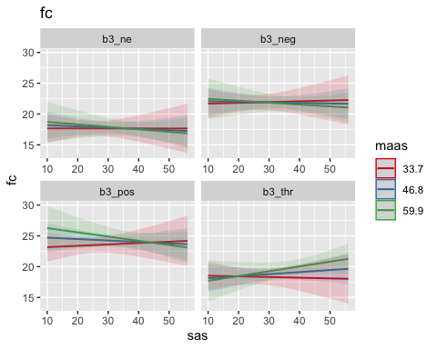
##
##
## [[1]]
## [[1]]$table
##
## [[1]]$p1
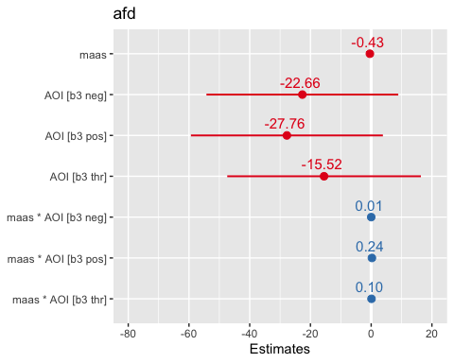
##
## [[1]]$p2
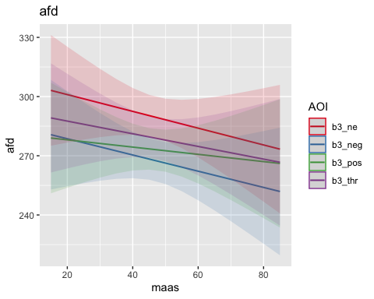
##
##
## [[2]]
## [[2]]$table
##
## [[2]]$p1
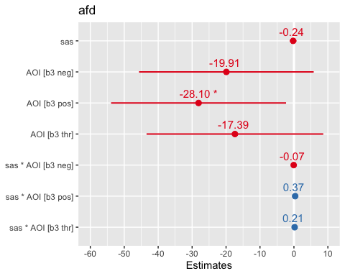
##
## [[2]]$p2
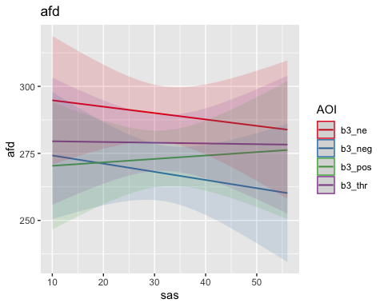
##
##
## [[3]]
## [[3]]$table
##
## [[3]]$p1
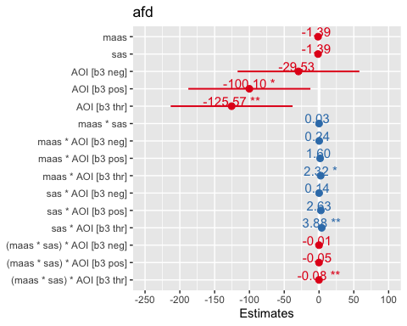
##
## [[3]]$p2
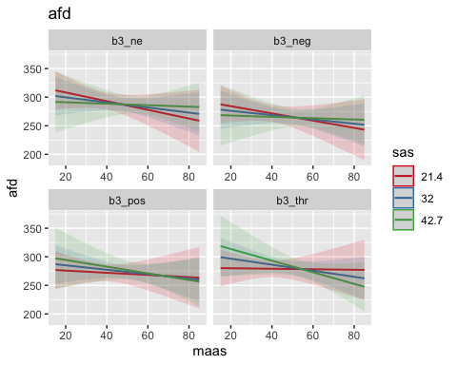
##
## [[3]]$p3
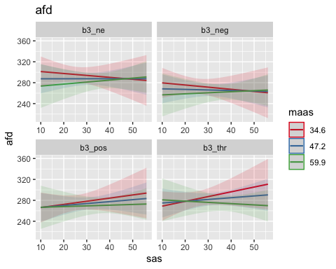
##
##
## [[1]]
## [[1]]$table
##
## [[1]]$p1
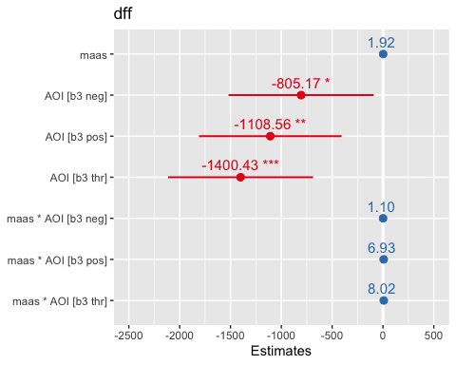
##
## [[1]]$p2
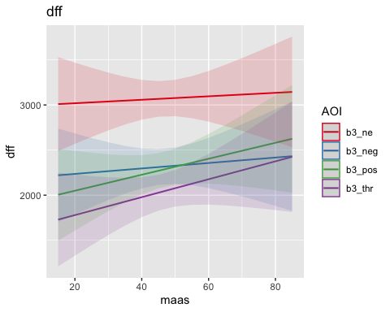
##
##
## [[2]]
## [[2]]$table
##
## [[2]]$p1
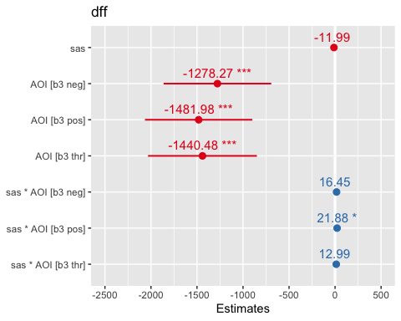
##
## [[2]]$p2
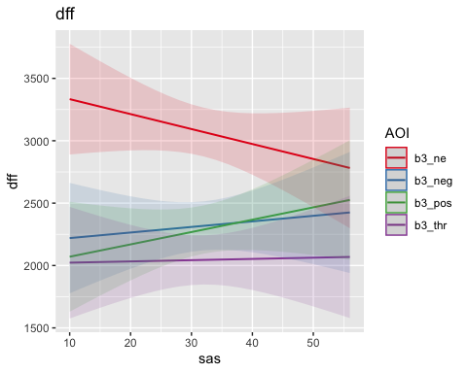
##
##
## [[3]]
## [[3]]$table
##
## [[3]]$p1
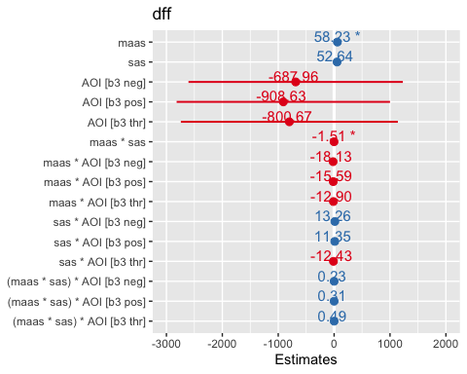
##
## [[3]]$p2
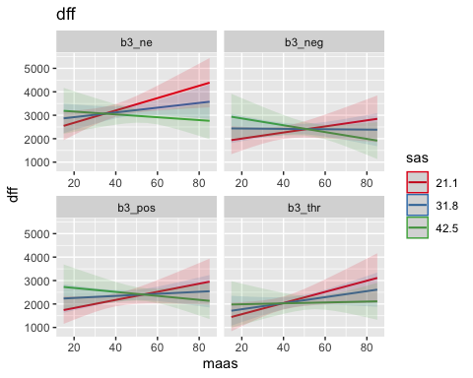
##
## [[3]]$p3
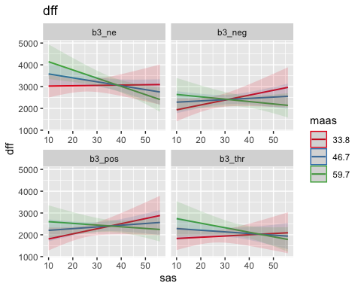
##
##
## [[1]]
## [[1]]$table
##
## [[1]]$p1
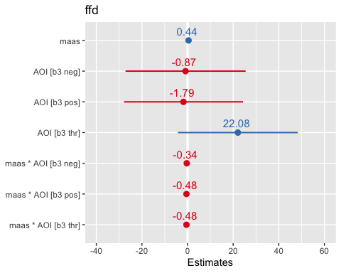
##
## [[1]]$p2
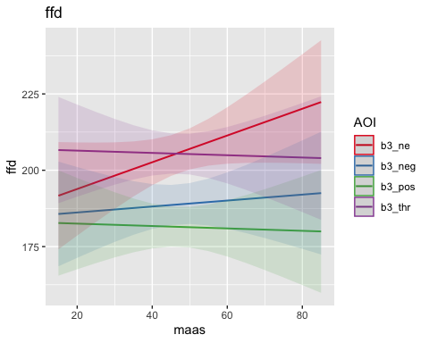
##
##
## [[2]]
## [[2]]$table
##
## [[2]]$p1
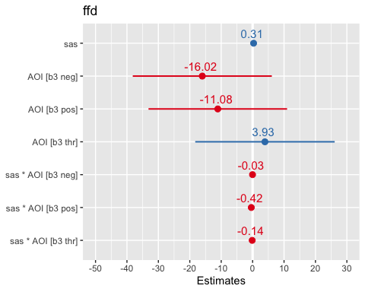
##
## [[2]]$p2
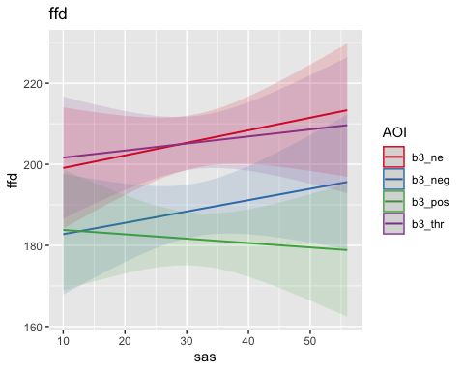
##
##
## [[3]]
## [[3]]$table
##
## [[3]]$p1
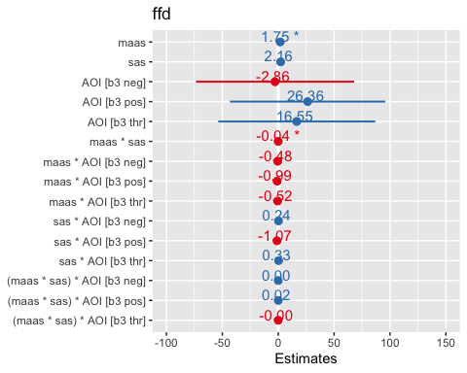
##
## [[3]]$p2
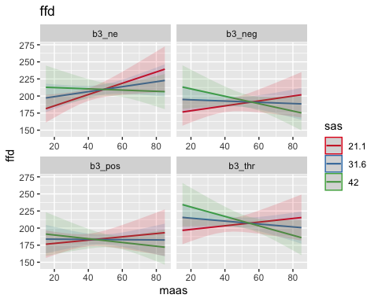
##
## [[3]]$p3
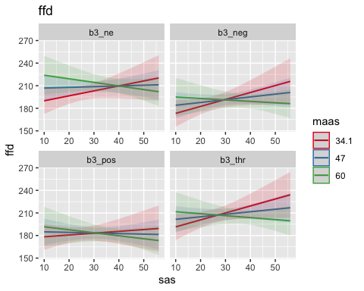
##
##
## [[1]]
## [[1]]$table
##
## [[1]]$p1
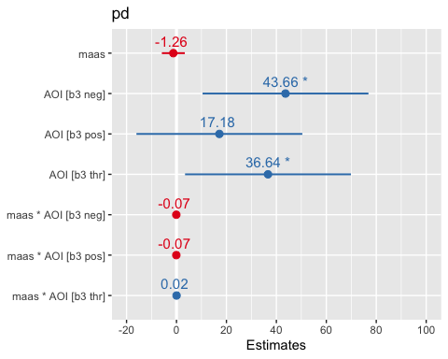
##
## [[1]]$p2
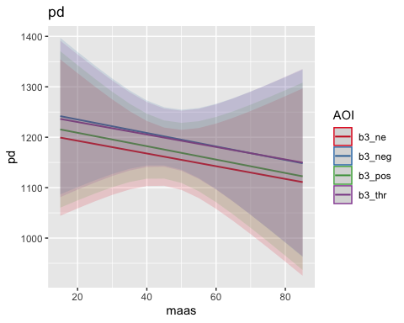
##
##
## [[2]]
## [[2]]$table
##
## [[2]]$p1
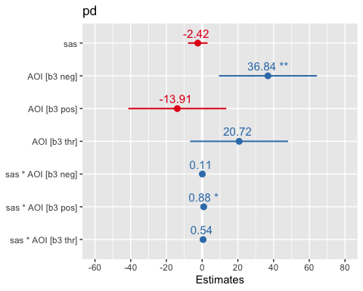
##
## [[2]]$p2
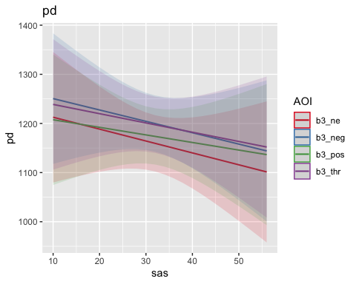
##
##
## [[3]]
## [[3]]$table
##
## [[3]]$p1
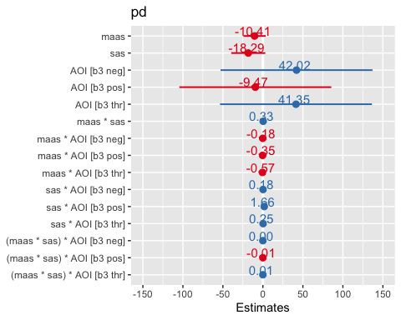
##
## [[3]]$p2
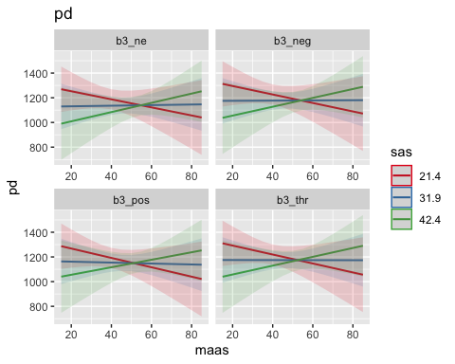
##
## [[3]]$p3
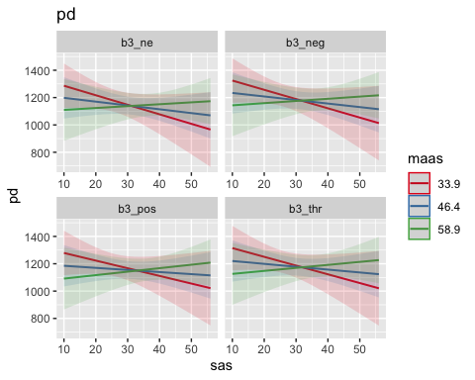
##
##
## [[1]]
## [[1]]$table
##
## [[1]]$p1
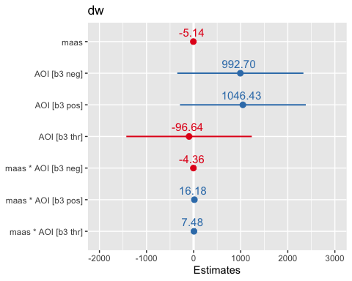
##
## [[1]]$p2
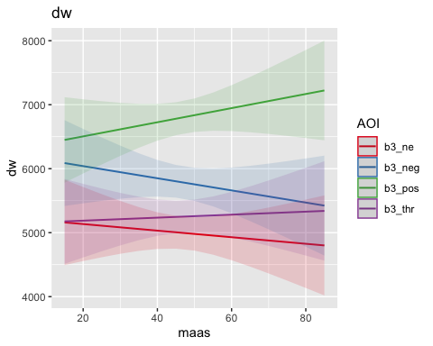
##
##
## [[2]]
## [[2]]$table
##
## [[2]]$p1
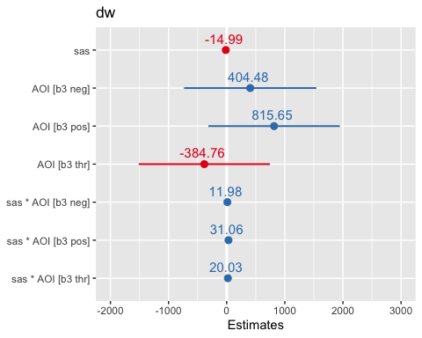
##
## [[2]]$p2
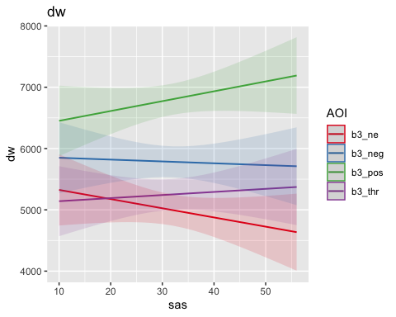
##
##
## [[3]]
## [[3]]$table
##
## [[3]]$p1
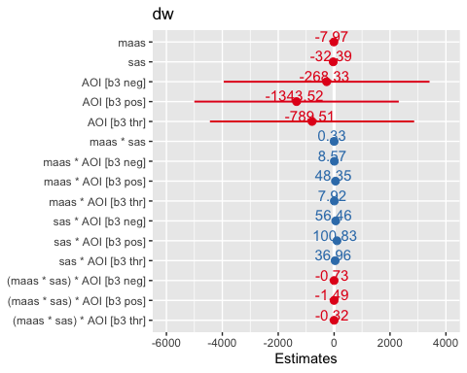
##
## [[3]]$p2
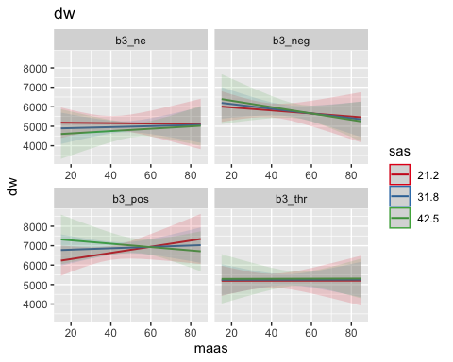
##
## [[3]]$p3
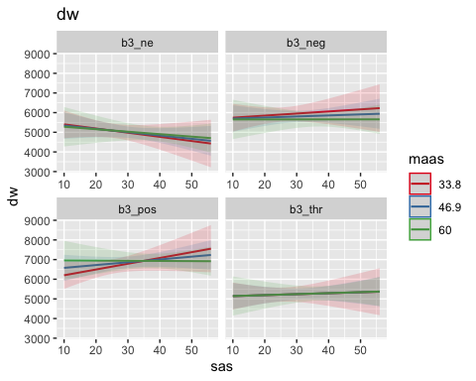
##
##
## [[1]]
## [[1]]$table
##
## [[1]]$p1
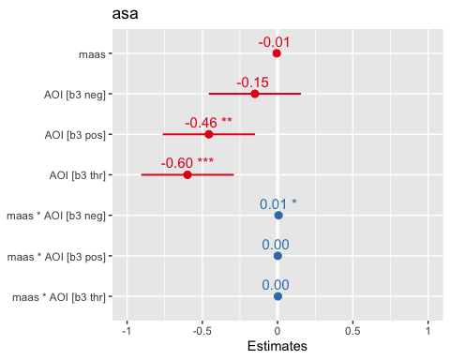
##
## [[1]]$p2
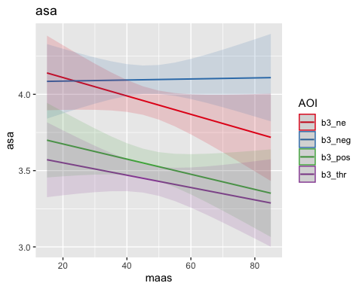
##
##
## [[2]]
## [[2]]$table
##
## [[2]]$p1
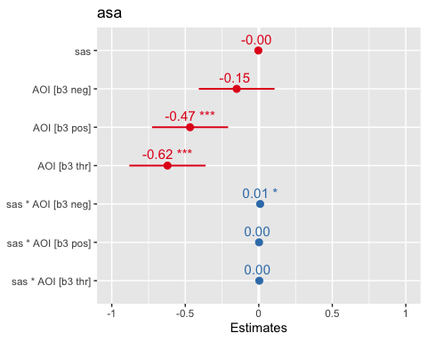
##
## [[2]]$p2
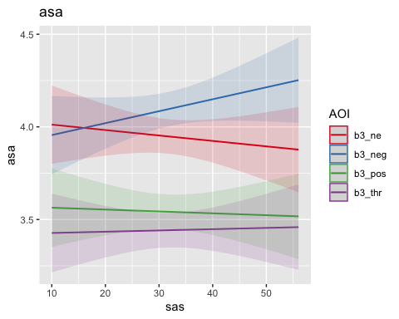
##
##
## [[3]]
## [[3]]$table
##
## [[3]]$p1
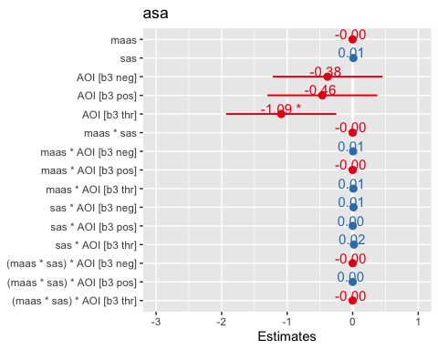
##
## [[3]]$p2
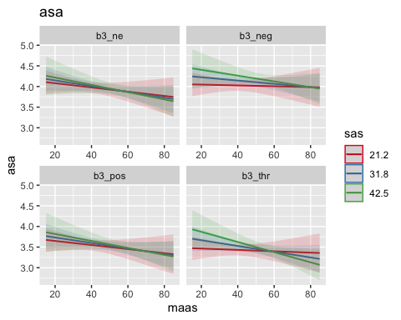
##
## [[3]]$p3
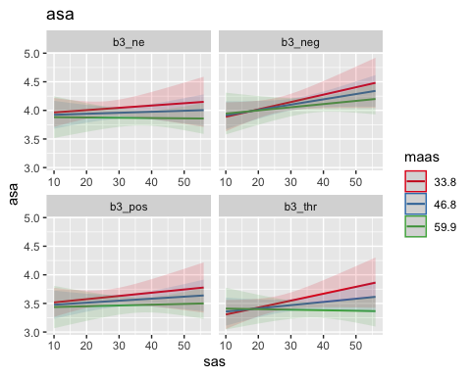
##
##
## [[1]]
## [[1]]$table
##
## [[1]]$p1
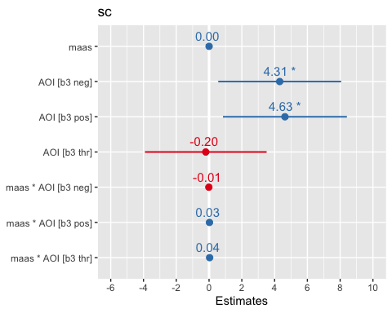
##
## [[1]]$p2
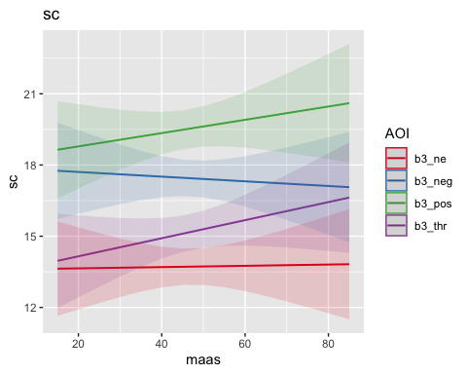
##
##
## [[2]]
## [[2]]$table
##
## [[2]]$p1
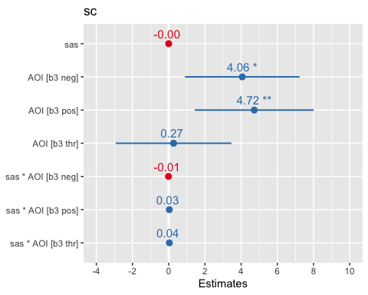
##
## [[2]]$p2
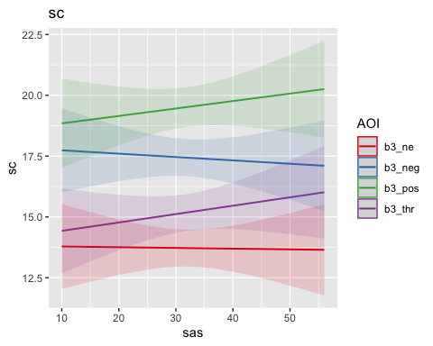
##
##
## [[3]]
## [[3]]$table
##
## [[3]]$p1
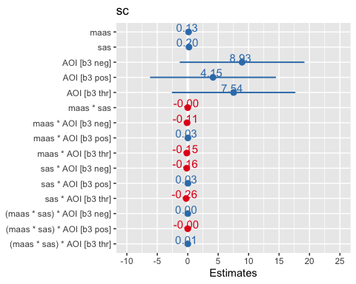
##
## [[3]]$p2
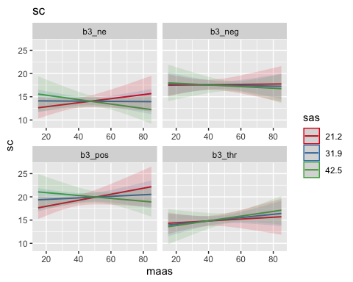
##
## [[3]]$p3
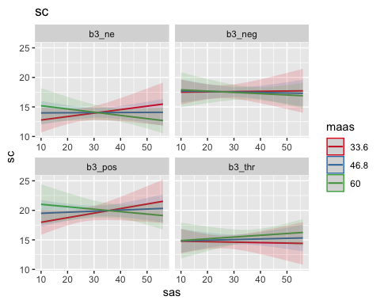
##
##
## [[1]]
## [[1]]$table
##
## [[1]]$p1
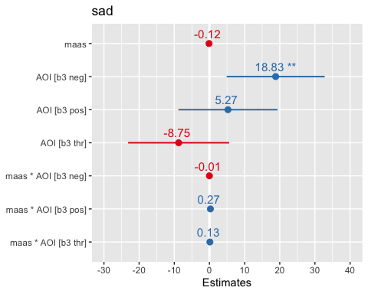
##
## [[1]]$p2
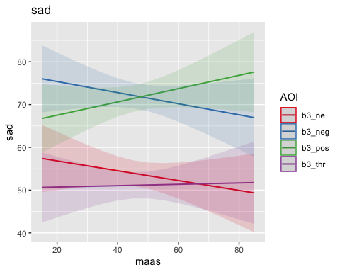
##
##
## [[2]]
## [[2]]$table
##
## [[2]]$p1
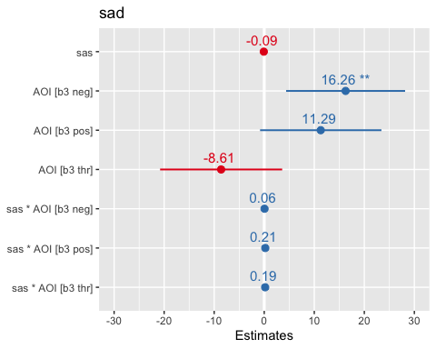
##
## [[2]]$p2
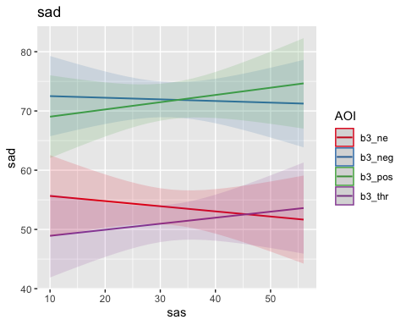
##
##
## [[3]]
## [[3]]$table
##
## [[3]]$p1
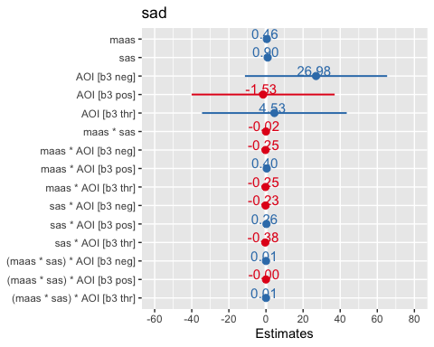
##
## [[3]]$p2
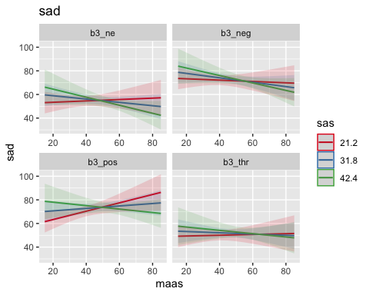
##
## [[3]]$p3
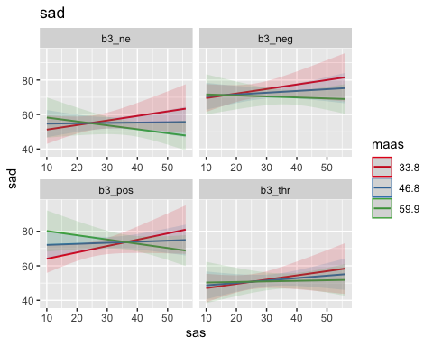
##
##
## [[1]]
## [[1]]$table
##
## [[1]]$p1
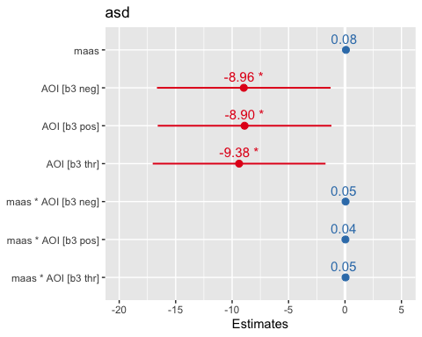
##
## [[1]]$p2
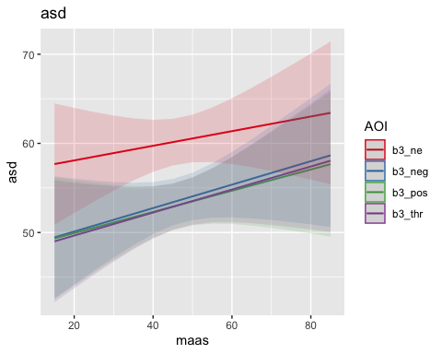
##
##
## [[2]]
## [[2]]$table
##
## [[2]]$p1
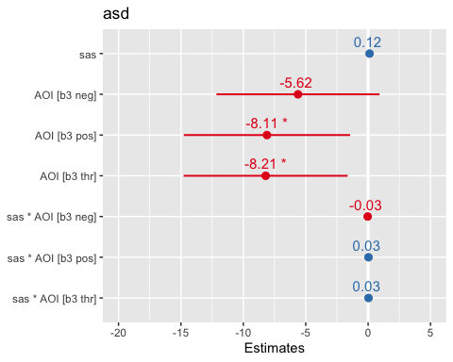
##
## [[2]]$p2
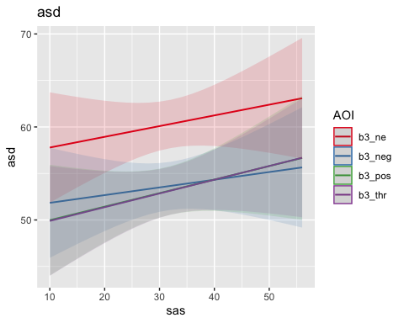
##
##
## [[3]]
## [[3]]$table
##
## [[3]]$p1
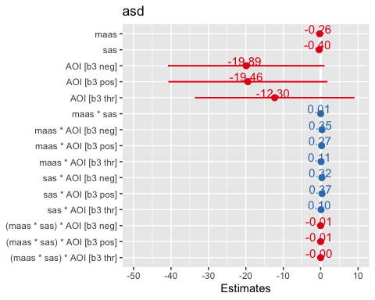
##
## [[3]]$p2
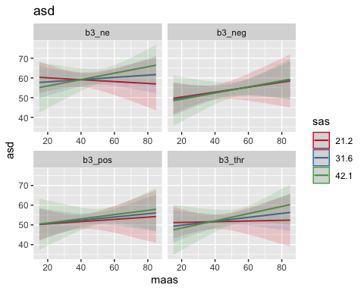
##
## [[3]]$p3
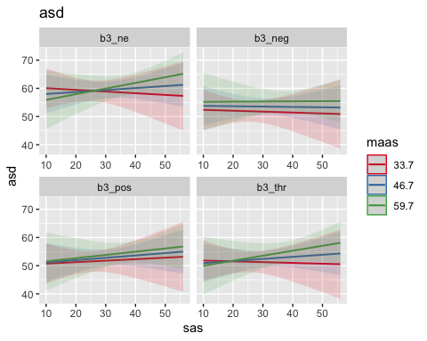
##
##
## [[1]]
## [[1]]$table
##
## [[1]]$p1
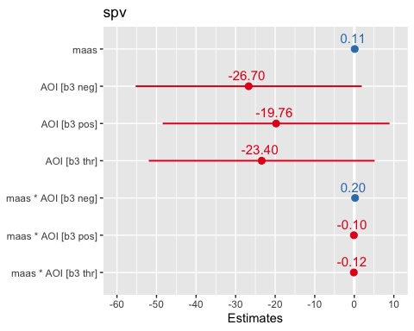
##
## [[1]]$p2
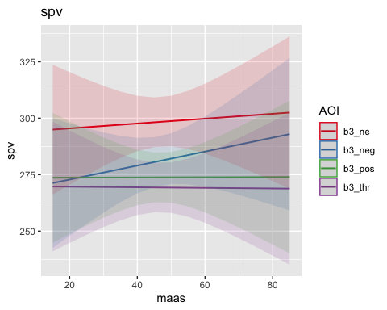
##
##
## [[2]]
## [[2]]$table
##
## [[2]]$p1
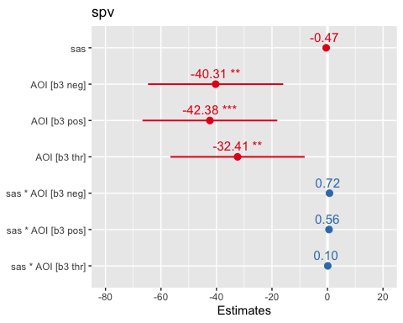
##
## [[2]]$p2
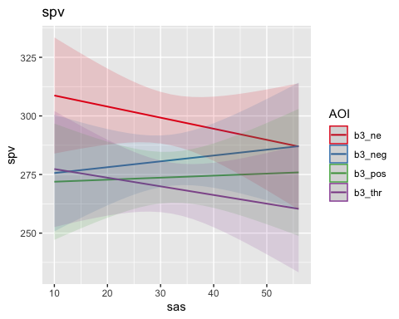
##
##
## [[3]]
## [[3]]$table
##
## [[3]]$p1
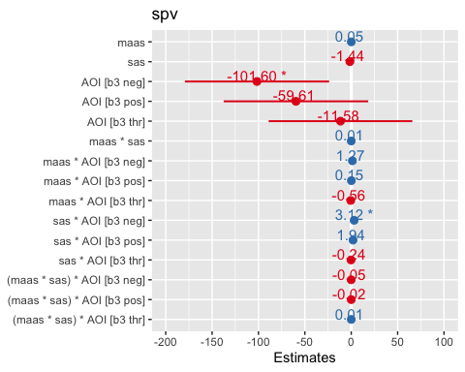
##
## [[3]]$p2
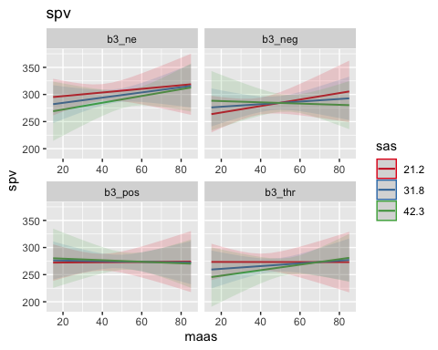
##
## [[3]]$p3
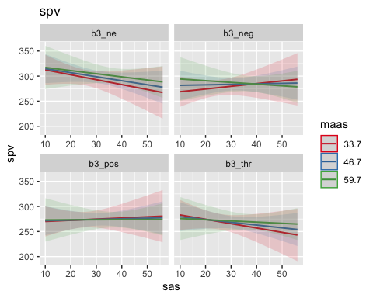
## [[1]]
## NULL
##
## [[2]]
## NULL
##
## [[3]]
## NULL
##
## [[4]]
## NULL
##
## [[5]]
## NULL
##
## [[6]]
## NULL
##
## [[7]]
## NULL
##
## [[8]]
## NULL
##
## [[9]]
## NULL
##
## [[10]]
## NULL
##
## [[11]]
## NULL

